Assessment Schedule – 2013

Science: Demonstrate understanding of biological ideas relating to genetic variation (90948)
Evidence Statement
 | Expected Coverage |  |  | Achievement |  | Merit |  | Excellence
ONE  (a)  (b)  (c) | Possible genotypes for an individual who has Huntington’s are HH or Hh.  Genotype of parent 9 (male) is: hh/homozygous  Genotype of parent 10 (female) is: Hh/heterozygous  Explains how parent 10 is Hh; eg her parents are Numbers 1 and 2. Her mother (number 2) is unaffected but her father (number 1) has Huntington’s disease. Number 2 is hh and number 1 must have at least one dominant allele. Because one allele is inherited from each, parent No. 2 must have given her daughter a recessive allele. She has inherited the dominant allele from her father, No. 1. She cannot be homozygous dominant HH because one of her offspring, No. 17, is not affected by the disease and is therefore hh.  Fraction of children with Huntington’s disease is 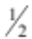.  Fraction of children without Huntington’s disease is . Phenotype ratio is 1:1.  Punnett squares predict probable offspring genotypes (thence the expected phenotypes) based on the gametes of the parents. Pedigree charts give the observed (actual) phenotypes. Since each fertilisation is a random event, it is by chance whether the offspring of number 10 inherits the dominant H allele and therefore has Huntington’s or the recessive h allele and does not have the disease. In the pedigree chart 3 of the 4 offspring have the disease but only 2 out of 4 would have been predicted from the Punnett square. |  |  | - States BOTH possible genotypes for individual with Huntington’s.  OR  If (one) H is present, the offspring will have Huntington’s disease.  - States genotype of number 9 as hh.  AND  States Genotype of number 10 as Hh.  - Correct Punnett square  (Hh × hh)  - Gives correct fractions.  OR  Ratio (if Punnett square incorrect, gives correct fraction from Punnett square).  - 10 gets a recessive allele / h from 2 OR gives a recessive / h to 17 / unaffected child.  - Punnett square predicts probable outcomes, but pedigree charts give what actually happened. Each fertilisation is random/outcomes for each child are unrelated.  - Sample size too small to be accurate. |  | - Explains that parent / female 10 must be heterozygous as her mother did not have the disease so No 10 could not be HH.  OR  Explains that parent / female 10 must be heterozygous as her offspring Number 17 did not have the disease so must have inherited the recessive allele from both parents, therefore No. 10 could not be HH.  - All offspring from parent 9 hh will inherit one recessive allele and have 50% chance of inheriting either H or h from parent 10, so offspring have 50% chance of having Huntington’s disease.  - Explains that Punnett squares only predict the outcome but it may differ because each fertilisation / combination of alleles or gametes is a random event.  - Allele combinations of the genotype. |  | - Comprehensive explanation regarding Number 10 being Hh. Must link across parental generation (numbers 1 and 2) AND filial generation (numbers 16, 17, 18 and 19).  Links the explanation of the disease being dominant due to parents at No. 9 and 10. Number 9 is hh and unaffected and number 10 is Hh and has disease with the parents of number 10 being number 1 and 2; number 2 is unaffected therefore hh, so daughter must have inherited one recessive allele from mother regardless of whether father (number 1) HH or Hh.  - Links the explanation of the inheritable nature of the dominant allele with the random nature of each fertilisation.  Eg, since each fertilisation is a random event, there is a 50% chance whether the offspring of number 10 inherits the dominant H allele and therefore has Huntington’s or the recessive h allele and does not have the disease.
   | H | h
  h | Hh | hh
  h | Hh | hh
Not achieved |  |  |  | Achievement |  | Achievement with Merit |  | Achievement with Excellence
NØ |  | N1 | N2 | A3 | A4 | M5 | M6 | E7 | E8
No response OR no relevant evidence |  | Describes ONE idea at Achievement level, eg correct Punnett square | Describes TWO ideas at Achievement level, eg correct Punnett and correct phenotype ratio | Describes THREE ideas at Achievement level | Describes FOUR ideas at Achievement level | Covers ONE aspect at Merit level | Covers TWO aspects at Merit level | Discussion includes ONE aspects at Excellence level | Discussion includes BOTH aspects at Excellence level

 |  | Expected Coverage |  | Achievement |  | Merit |  | Excellence
TWO  (a)  (b) |  | Chromosomes are made up of DNA. DNA is a large molecule that is coiled into a double helix (twisted ladder structure). It is responsible for determining the phenotype of an organism. Along this molecule are bases. These bases pair up; A always pairs with T, and G with C.  A sequence of bases which codes for a particular trait (eg, eye colour) is called a gene.  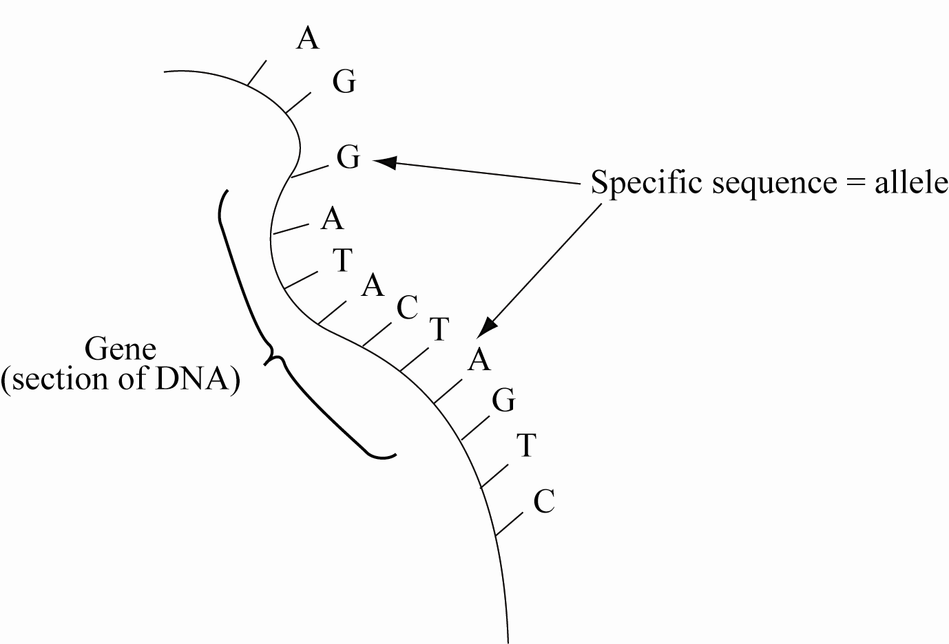  The different versions of each gene are called alleles, and these show the different variations of each characteristic, eg brown / blue eyes. Because chromosomes come in pairs for each trait, there will be two possible alleles. These different versions of genes (alleles) occur as the DNA base sequence is different.  This combination of alleles for each trait is called the genotype; this can be any combination of two of the available alleles. The genotype determines the phenotype (the physical appearance) of the organism. Whichever alleles are present may be expressed. Dominant alleles (B) will be expressed over recessive alleles (b).  For the child to have blue eyes they must have a genotype of bb (ie have both recessive alleles). If a dominant allele, B is present then brown eyes would be seen.  In order to have a genotype of bb, each parent must have given a b (recessive allele). Both parents have brown eyes so therefore they both must have a dominant allele (B) and because each parent passes on a recessive allele the genotype of each parent must be Bb. The grandparents could have a genotype of bb, Bb, or BB. It is not possible to say for sure, but at least one of the grandparents on each side must pass on a recessive allele (b) in order for each parent to have a recessive allele to pass on to the child. Punnett square(s) may be used to show this but must be explained. |  | - Double helix structure described.  - Identifies the 4 bases and their pairings.  - A relationship described between any pair of terms (DNA / gene / allele / genotype / phenotype / chromosome).  - Indicates that alleles of genes have a different base sequence / arrangement.  - States that the child has genotype of bb.  - States that in order for the child to have blue eyes, each parent must have passed on a recessive allele.  OR  Each parent must have be heterozygous / have a b.  - Draws a correct Punnet square. |  | - Explains the relationship between genotype / phenotype.  - Explains the relationship between DNA, a gene, and an allele.  - Explains that each parent must have genotype of Bb, linking that they must have a dominant allele as they have brown eyes but must also have a recessive allele so they can pass it on to the child.  OR  That the grandparent / s must have at least one recessive allele / b to pass to the parents. |  | - Explanation of the structural relationship between DNA, genes and alleles, and chromosomes, with the explanation of the production of a particular feature (phenotype) and the variation of alleles (genotype) that cause this feature.  - Comprehensively links the genotypes and phenotypes of all three generations.  (eg explains why it is not possible to determine the genotypes and phenotypes of the grandparents or explains that grandparents must contribute recessive alleles)
   | B | b
  B | BB | Bb
  b | Bb | bb
 | Not achieved |  |  | Achievement |  | Achievement with Merit |  | Achievement with Excellence
 | NØ | N1 | N2 | A3 | A4 | M5 | M6 | E7 | E8
 | No evidence OR no relevant evidence | Describes ONE idea at the Achievement level | Describes TWO ideas at the Achievement level | Describes THREE ideas at the Achievement level | Describes FOUR ideas at the Achievement level | Covers ONE aspect at Merit level | Covers TWO aspects at Merit level | Covers ONE aspect at Excellence level | Covers TWO aspects at Excellence level

 | Expected Coverage |  |  |  | Achievement |  |  | Merit |  |  | Excellence
THREE  (a)  (b)  (c) | - Possible disadvantages: need two parents that are able to reproduce, if conditions are stable could introduce variation, which may be counterproductive.  - Gametes are sex cells (sperm and egg) which are formed in the testes and ovaries. During gamete formation (meiosis), the homologous chromosomes are halved and the gamete will inherit one of each pair of chromosomes. Which chromosome is passed on is random due to the process of independent assortment.  - During fertilisation, the gametes combine and the resulting offspring will have two alleles – they may inherit two alleles the same, homozygous, and show that characteristic or they may inherit one of each allele, heterozygous in which case they will show the dominant allele in their phenotype.  - Genetic variation: variety within a population, eg different alleles possible for each gene. The advantage of variation to a population is that it may see some individuals survive if environment changes, in this case if drought occurs. Because of variation, not all individuals will be wiped out. Those with favourable alleles / traits / phenotypes will survive and be able to pass on genetic material to offspring and therefore survival of the species occurs. |  |  |  | - Identifies one disadvantage.  Eg: Need two parents; not as efficient at passing on ‘good’ genes; only females produce offspring; male gamete must meet female gamete; fertilisation needed.  - Describes that during gamete formation the gamete will contain only ONE of each pair of a chromosome / half the chromosome number  - States how variation is caused during meiosis (eg independent assortment/ allele shuffling / gametes are unique)  - Describes fertilisation as meeting of male and female gametes/sperm and egg  - Describes that at fertilisation individual inherits from male and female parents and it is random.  OR  Variation due to 2 parents.  - Indicates that the separation of alleles / chromosomes during meiosis results in new combinations of alleles.  - Defines the term ‘genetic variation’.  - Gives example why variation is good. |  |  | - Explains why TWO disadvantages given in (a) are disadvantageous.  - Explains how gamete formation / meiosis results in variation (shuffling / indep assortment / 1 / 2 chromosomes).  - Explains that during fertilisation a gamete is inherited from each parent, and that the combination of alleles is random.  - Explains why differences in traits / characteristics / phenotypes may be of benefit if the environment changes. |  |  | - Comprehensive explanation covering how gamete formation results in variation, ie only one of a pair of chromosomes is inherited as a result of meiosis, and it is random chance which of each pair of chromosomes are passed on.  AND  In fertilisation, the gametes combine randomly to gave unique offspring / variations.  - Links the explanation of why genetic variation within a population is important for the survival of the species in a changing environment (with examples) with the explanation of how inherited variation is constantly being generated by the process of meiosis, through the reshuffling of alleles.
Not achieved |  |  |  | Achievement |  |  | Achievement with Merit |  |  | Achievement with Excellence
NØ |  | N1 | N2 | A3 |  | A4 | M5 |  | M6 | E7 |  | E8
No evidence OR no relevant evidence |  | Describes ONE PARTIAL idea at Achievement level | Describes ONE idea at Achievement level | Describes TWO ideas at Achievement level |  | Describes THREE ideas at Achievement level | Covers ONE aspect at Merit level |  | Covers TWO aspects at Merit level | Discussion includes BOTH aspects at Excellence level with one less fully developed. |  | Discussion includes BOTH aspects at Excellence level

 | Expected Coverage |  |  | Achievement |  | Merit |  | Excellence
FOUR  (a)  (b) | - Definition: Phenotype – an organism’s observable characteristics or traits based on the genotype.  - The less aggressive Tasmanian devils are biting others less, therefore have less chance of being injured. The less aggressive Devils may expend less energy fighting and spend more time foraging.  - Phenotypic ratio is the pattern of offspring based on observable characteristics.  - The aggressive devils have decreased life expectancy due to increased disease and injury, therefore have fewer breeding cycles and consequently have fewer offspring during their shortened life.  - The unaffected devils have a normal life expectancy and therefore more breeding cycles, resulting in more offspring during the lifetime of the individual.  - The less aggressive trait has a greater chance of increasing in the population as there will be more of them to reproduce. |  |  | - Defines phenotype (“what it looks like” must be accompanied by an example).  - States less aggressive devils have less chance of contracting disease or injury OR vice versa.  - States less aggressive devils live longer / don’t die OR vice versa (more aggressive die earlier).  - Less aggressive devils will have more offspring OR vice versa.  - States that less aggressive genetics will increase / pass to offspring. |  | In-depth explanation:  - Explains how the less aggressive devils are biting less and therefore have reduced chance of contracting disease or injury, whereas the more aggressive devils are biting more frequently and have increased chance of being injured or contracting disease.  - Explains how the more aggressive devils will have fewer offspring as they will survive to breed for a shorter time due to injury or disease.  OR  That less aggressive devils will survive longer, and therefore survive to breed longer / more offspring / increase in proportion of non-aggressive. |  | - Comprehensive discussion of survival of the species links the phenotype of aggressiveness with increased early mortality and reduced reproduction/number of offspring.  Eg: The more aggressive Tasmanian devils are doing more biting so they have an increased chance of contracting a disease by biting another devil who has a disease / injury, and therefore have a reduced chance of surviving long enough to produce (a lot of) offspring.  OR the less aggressive devils have a decreased chance of dying early from their injuries, and therefore have an increased chance of surviving and producing (a lot of) offspring.  - Links the increased chance of survival of non-aggressive devils to an increase in the proportion of non-aggressive devils in the population (phenotypic ratio) to survival of the species, eg more likely to pass favourable allele to offspring so a higher proportion than aggressive devils which fight less and live longer than aggressive individuals, decreasing extinction chances.
Not achieved |  |  |  | Achievement |  | Achievement with Merit |  | Achievement with Excellence
N0 |  | N1 | N2 | A3 | A4 | M5 | M6 | E7 | E8
No evidence OR no relevant evidence. |  | Describes ONE partial idea at Achievement level. | Describes ONE idea at Achievement level. | Describes TWO ideas at Achievement level. | Describes THREE ideas at Achievement level. | Covers ONE aspect at Merit level. | Covers TWO aspects at Merit level. | Discussion includes BOTH aspects at Excellence level with one less fully developed. | Discussion includes BOTH aspects at Excellence level.

Judgement Statement
 | Not Achieved | Achievement | Achievement with Merit | Achievement with Excellence
Score range | 0 – 9 | 10 – 17 | 18 – 24 | 25 – 32

